***AIDS MICROPROCESSOR LAB S21 BATCH (2023-24)***

***Experiment 2(a) Title: Assembly language programming to add two 16 bit hexadecimal numbers using software tool TASM 1.4***

***Name of student: Meet Raut Class Roll Number: 2201084***

***Date of Performance: 29/01/2024***

***Batch: S2-1 Timing: 3:00-5:00 Date of Submission: 29/01/2024***

***Assembly language code***

*data segment # Data segment*

*a dw 0307h # variable a define first 16 bit number*

*b dw 0502h # variable b define second 16 bit number*

*sum dw ? #variable sum define result of addition of two 16 bit data*

*Numbers*

*data ends # Assemble directives*

*code segment*

*assume cs:code, ds:data # Assemble directives defining cs and ds*

*start: # start of code segment*

*mov ax,data # moving data to ax register- initialization process*

*mov ds,ax # moving ax to dx register -- initialization process*

*mov ax,a # moving first number to ax register*

*mov bx,b # moving second number to bx register*

*add ax,bx # Addition of bx number to ax and result stored in ax*

*mov sum,ax # result stored in ax moved to variable sum*

*int 3 # breakpoint interrupt*

*code ends # Assembler directives to end code*

*end start # Assembler directives to end start*

*Result of addition:*

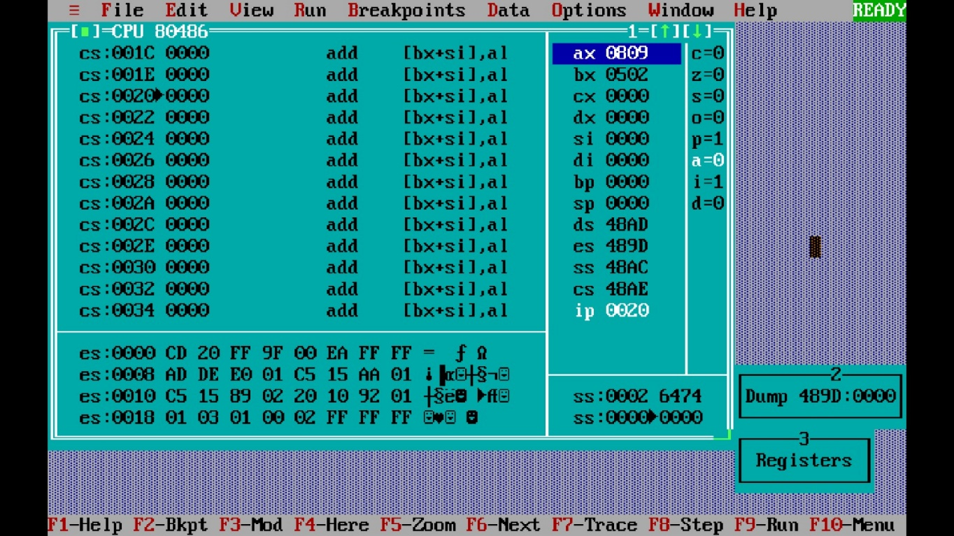

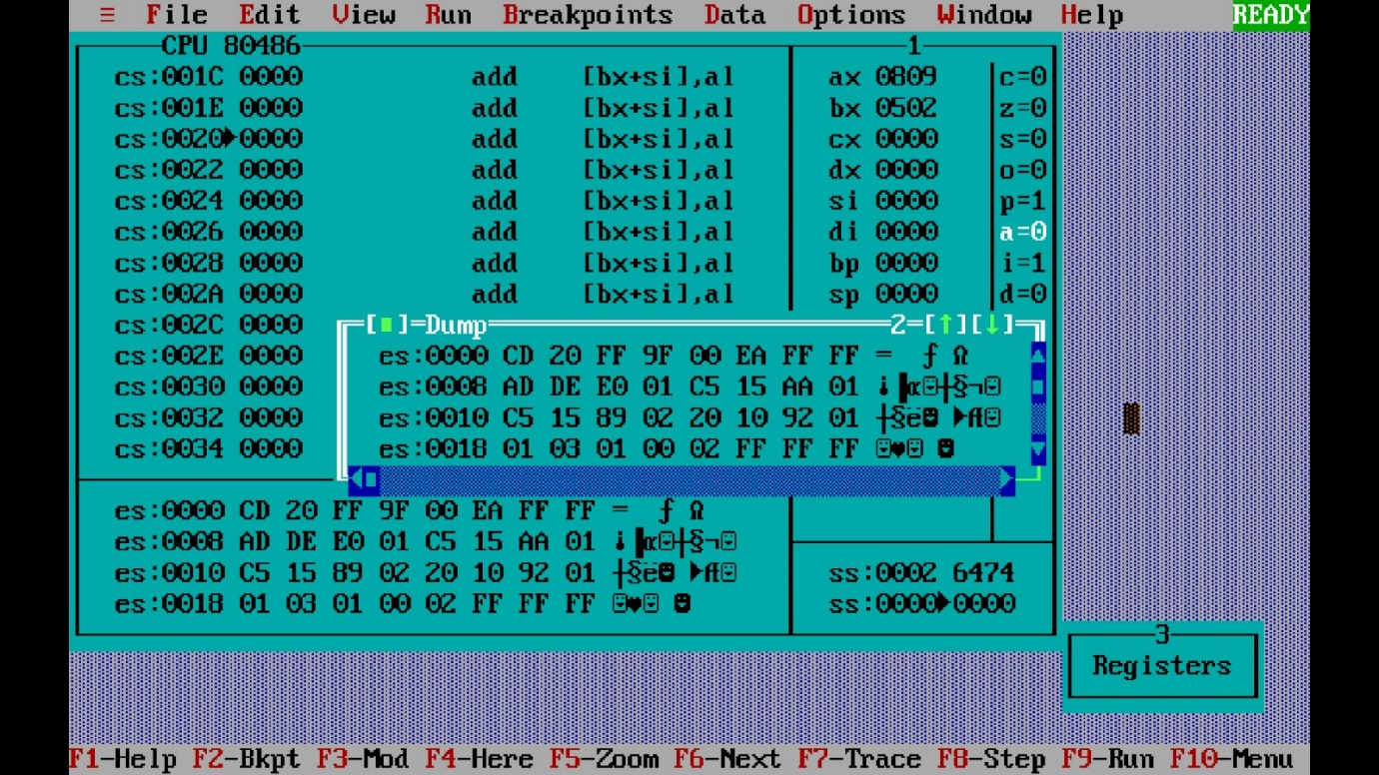

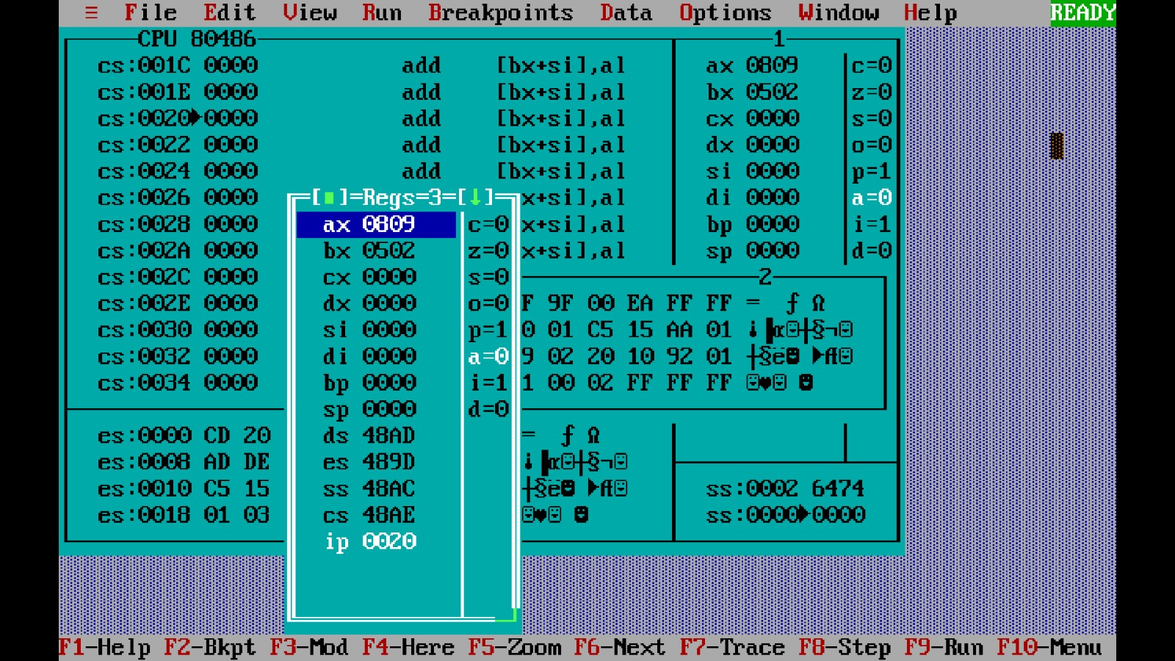

***Experiment 2(b) Title: Assembly language programming to add two 16 bit hexadecimal numbers with carry using software tool TASM 1.4***

***Name of student: Meet Raut Class Roll Number: 2201084***

***Date of Performance: 29/01/2024***

***Batch: S2-1 Timing: 3:00-5:00 Date of Submission: 29/01/2024***

***Assembly language code***

*data segment # Data segment*

*a dw 0307h # variable a define first 16 bit number*

*b dw 0502h # variable b define second 16 bit number*

*sum dw ? #variable sum define result of addition of two 16 bit*

*data Numbers*

*carry dw ? #* *Variable 'Carry' defines a flag to indicate if there is a*

*carry during addition*

*data ends # Assemble directives*

*code segment*

*assume cs:code, ds:data # Assemble directives defining cs and ds*

*start: # start of code segment*

*mov ax,data # moving data to ax register- initialization process*

*mov ds,ax # moving ax to dx register -- initialization process*

*mov cx,0000h #* *Initialize cx register to 0 for counting carry*

*mov ax,a # moving first number to ax register*

*mov bx,b # moving second number to bx register*

*add ax,bx # Addition of bx number to ax and result stored in ax*

*jnc x #* *Jump to 'x' label if there is no carry*

*inc cx #* *Increment cx if there is a carry*

*x: mov sum,ax # result stored in ax moved to variable sum*

*mov carry,cx #* *Move the carry count in cx to the variable 'carry'*

*int 3 # breakpoint interrupt*

*code ends # Assembler directives to end code*

*end start # Assembler directives to end start*

*Result of addition:*

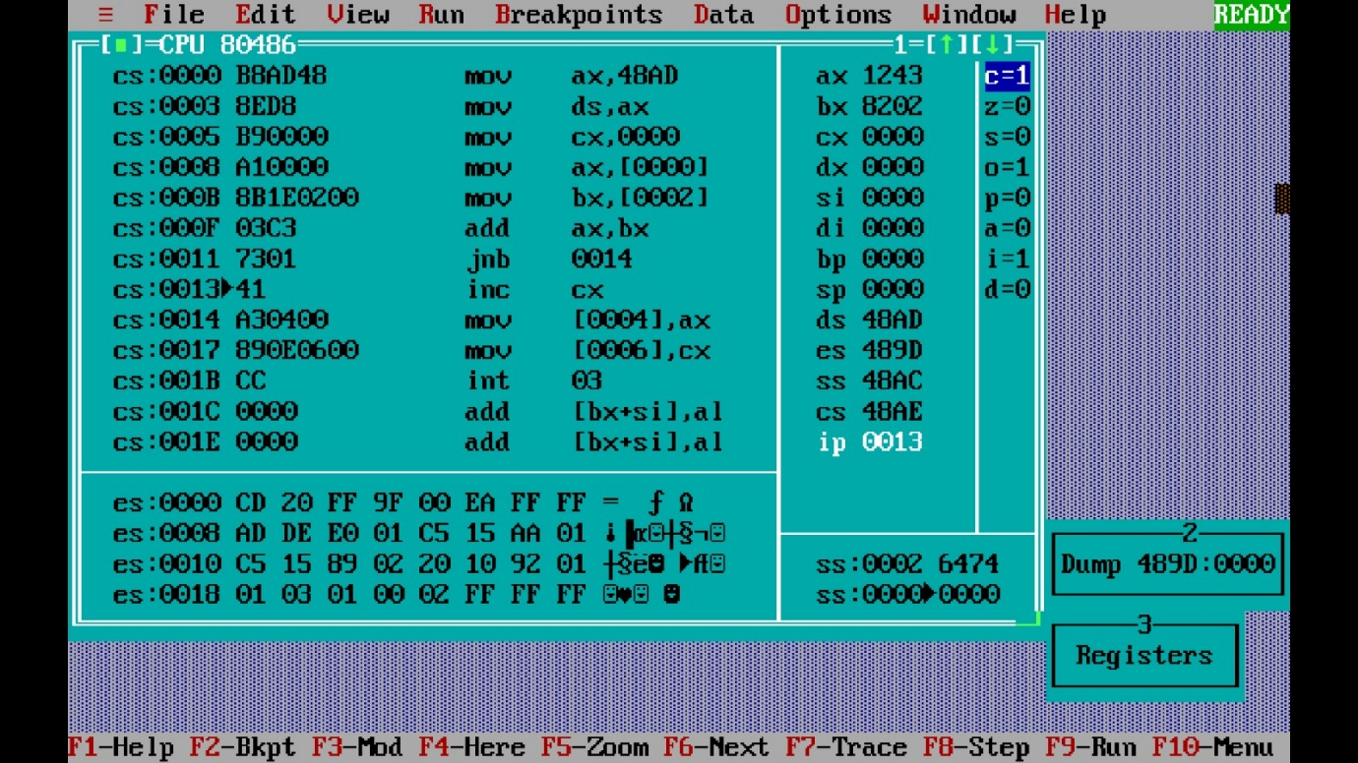

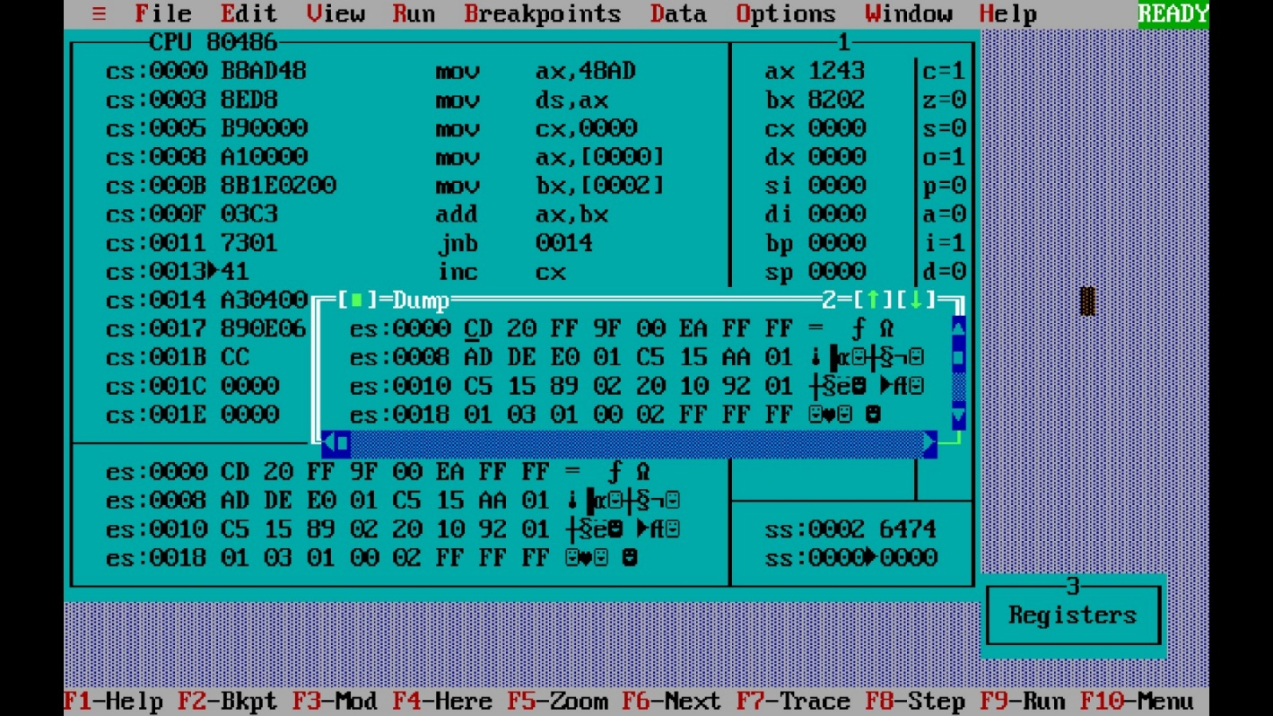

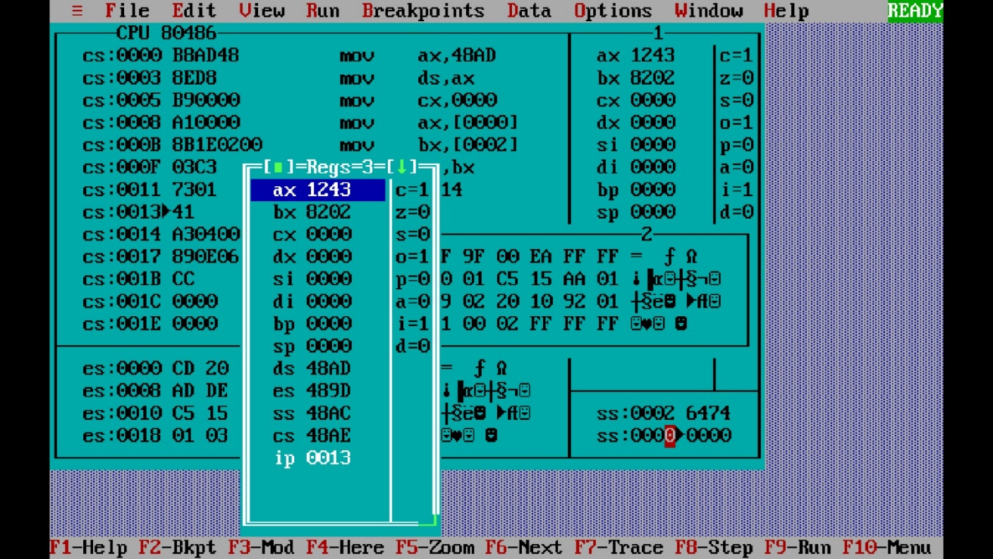

***Experiment 2(c) Title: Assembly language programming to subtract two 16 bit hexadecimal numbers using software tool TASM 1.4***

***Name of student: Meet Raut Class Roll Number: 2201084***

***Date of Performance: 05/02/2024***

***Batch: S2-1 Timing: 3:00-5:00 Date of Submission: 05/02/2024***

***Assembly language code***

*data segment # Data segment*

*a dw 9057h # variable a define first 16 bit number*

*b dw 8022h # variable b define second 16 bit number*

*diff dw ? #variable diff define result of subtraction of two 16 bit . data Numbers*

*data ends # Assemble directives*

*code segment*

*assume cs:code, ds:data # Assemble directives defining cs and ds*

*start: # start of code segment*

*mov ax,data # moving data to ax register- initialization process*

*mov ds,ax # moving ax to dx register -- initialization process*

*mov ax,a # moving first number to ax register*

*mov bx,b # moving second number to bx register*

*add ax,bx # Subtraction of bx number to ax and result stored in . . ax*

*mov diff,ax # result stored in ax moved to variable diff*

*int 3 # breakpoint interrupt*

*code ends # Assembler directives to end code*

*end start # Assembler directives to end start*

*Result of subtraction:*

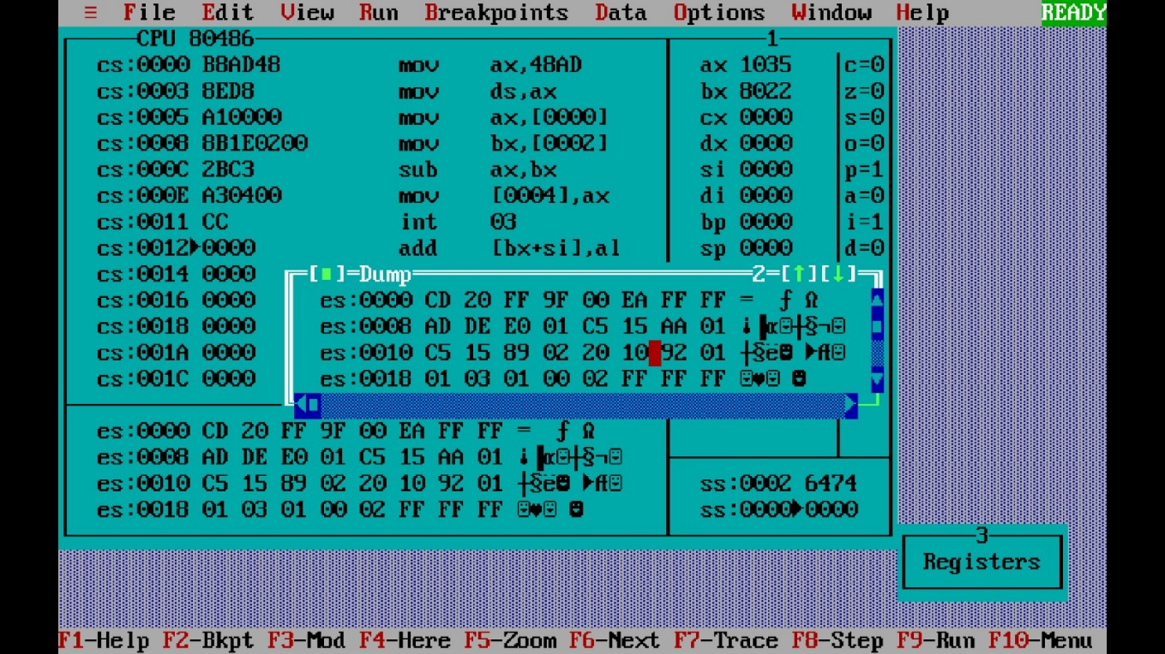

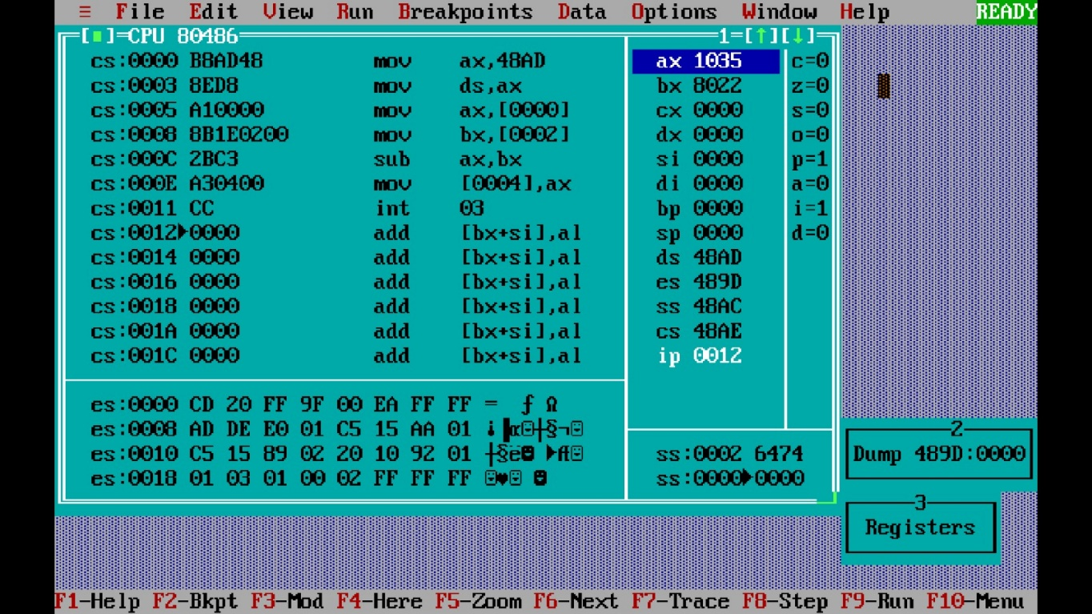

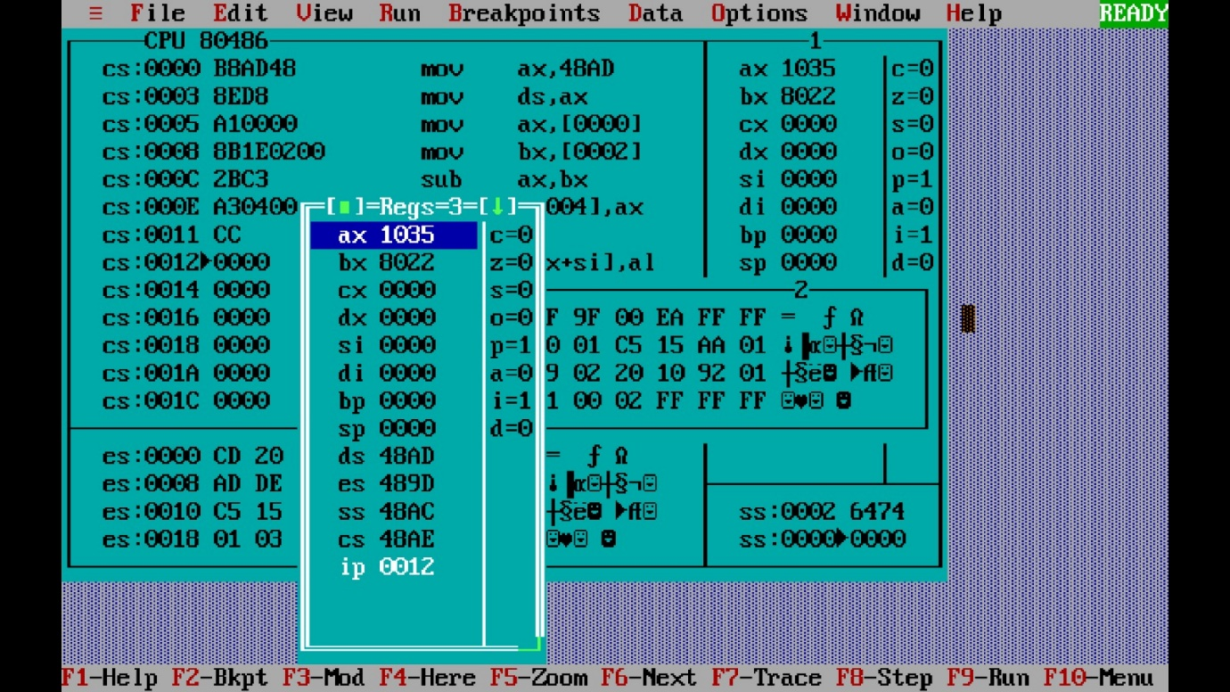

***Experiment 2(d) Title: Assembly language programming to subtract two 16 bit hexadecimal numbers with carry using software tool TASM 1.4***

***Name of student: Meet Raut Class Roll Number: 2201084***

***Date of Performance: 05/02/2024***

***Batch: S2-1 Timing: 3:00-5:00 Date of Submission: 05/02/2024***

***Assembly language code***

*data segment # Data segment*

*a dw 9305h # variable a define first 16 bit number*

*b dw 6157h # variable b define second 16 bit number*

*diff dw ? #variable diff define result of subtraction of two 16 bit*

*data Numbers*

*carry dw ? #* *Variable 'Carry' defines a flag to indicate if there is a*

*carry during subtraction*

*data ends # Assemble directives*

*code segment*

*assume cs:code, ds:data # Assemble directives defining cs and ds*

*start: # start of code segment*

*mov ax,data # moving data to ax register- initialization process*

*mov ds,ax # moving ax to dx register -- initialization process*

*mov cx,0000h #* *Initialize cx register to 0 for counting carry*

*mov ax,a # moving first number to ax register*

*mov bx,b # moving second number to bx register*

*sub ax,bx # Subtraction of bx number to ax and result stored in . ax*

*jnc x #* *Jump to 'x' label if there is no carry*

*inc cx #* *Increment cx if there is a carry*

*x: mov diff,ax # result stored in ax moved to variable diff*

*mov carry,cx #* *Move the carry count in cx to the variable 'carry'*

*int 3 # breakpoint interrupt*

*code ends # Assembler directives to end code*

*end start # Assembler directives to end start*

*Result of subtraction:*

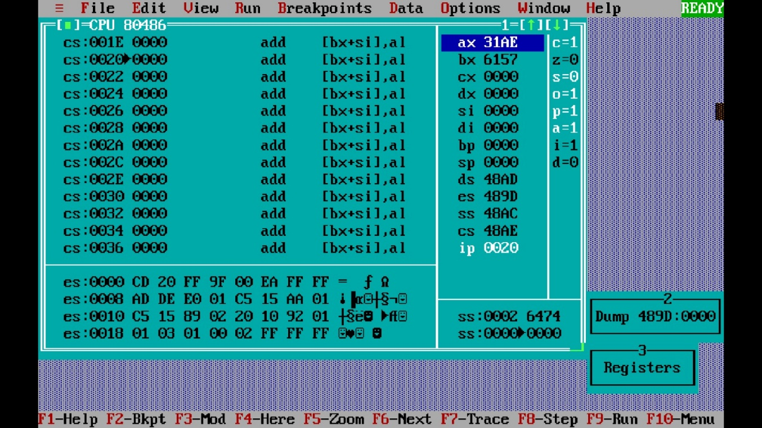

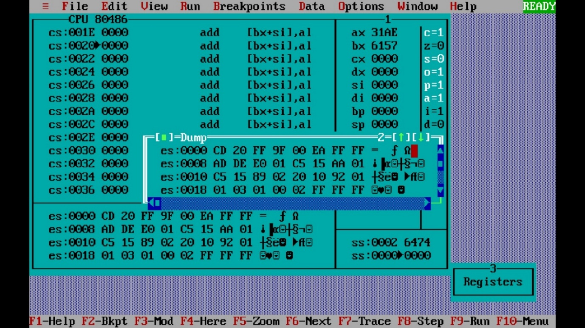

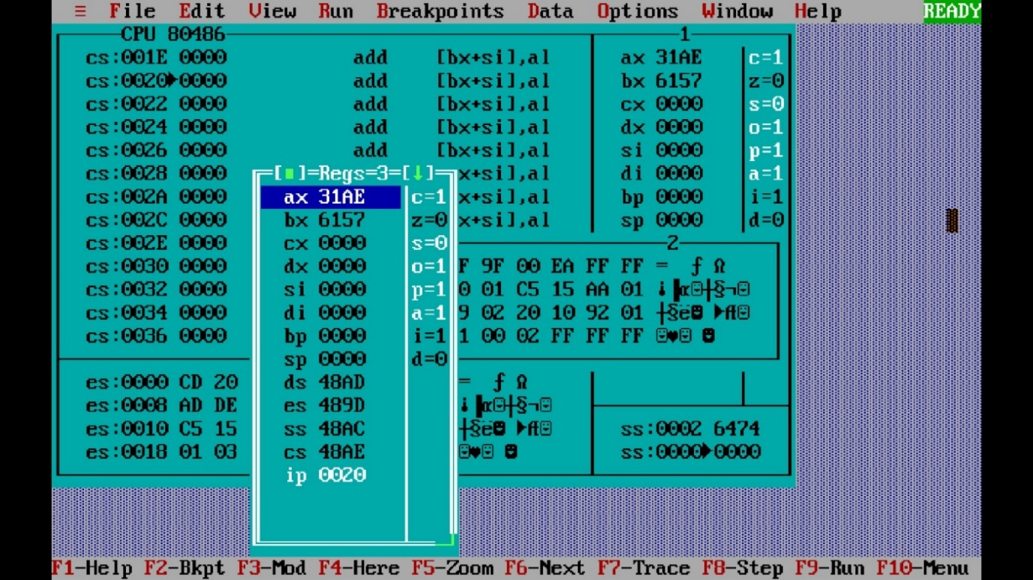

***Experiment 2(e) Title: Assembly language programming to multiply two 8 bit hexadecimal numbers using software tool TASM 1.4***

***Name of student: Meet Raut Class Roll Number: 2201084***

***Date of Performance: 05/02/2024***

***Batch: S2-1 Timing: 3:00-5:00 Date of Submission: 05/02/2024***

***Assembly language code***

*data segment # Data segment*

*a dB 0Fh # variable a define first 8 bit number*

*b dB 09h # variable b define second 8 bit number*

*mult dw ? #variable mult define result of multiplication of two 8 bit . . data Numbers*

*data ends # Assemble directives*

*code segment*

*assume cs:code, ds:data # Assemble directives defining cs and ds*

*start: # start of code segment*

*mov ax,data # moving data to ax register- initialization process*

*mov ds,ax # moving ax to dx register -- initialization process*

*mov al,a # moving first number to al register*

*mov bl,b # moving second number to bl register*

*mul bl # multiplication of two numbers*

*mov mult,ax # result stored in ax moved to variable mult*

*mov ah, 4Ch*

*int 21h # breakpoint interrupt*

*code ends # Assembler directives to end code*

*end start # Assembler directives to end start*

*Result of multiplication:*

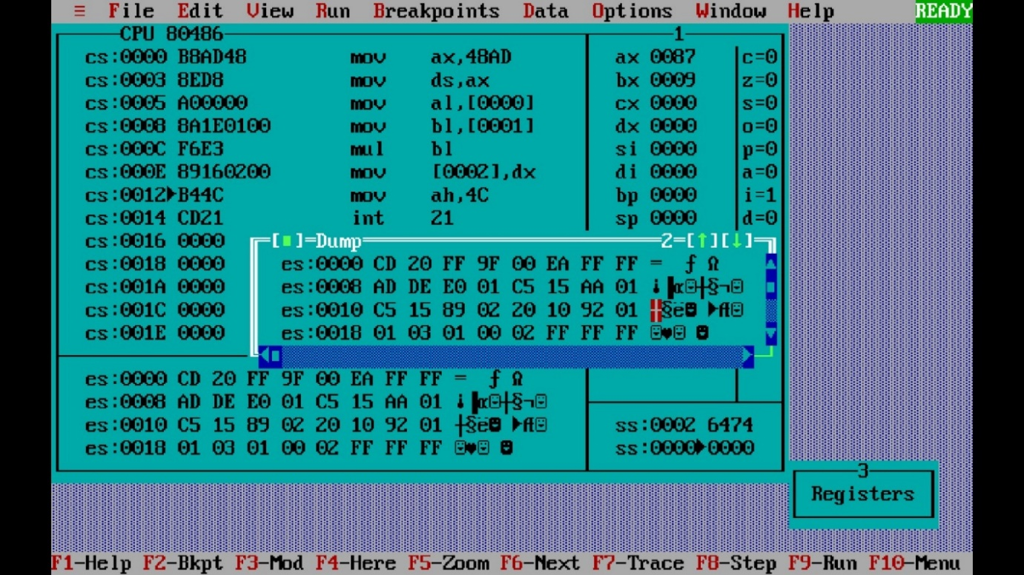

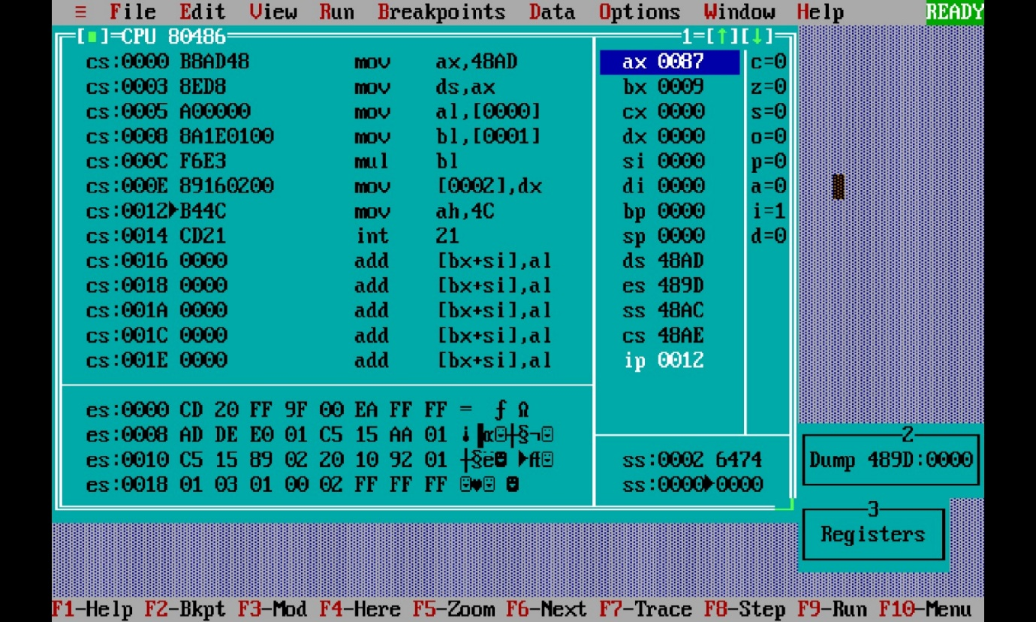

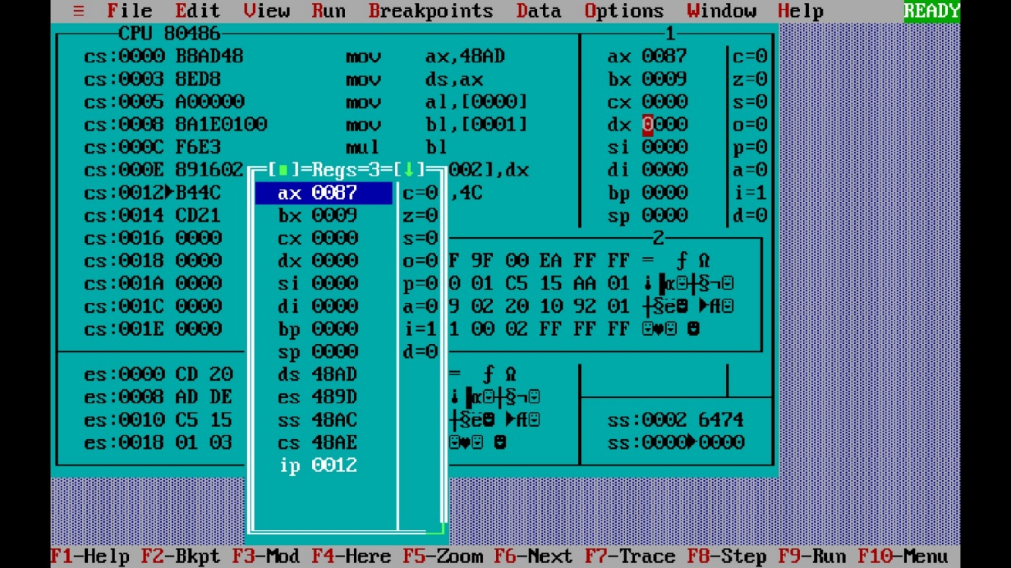

***Experiment 2(f) Title: Assembly language programming to multiply two unsigned 16 bit numbers using software tool TASM 1.4***

***Name of student: Meet Raut Class Roll Number: 2201084***

***Date of Performance: 05/02/2024***

***Batch: S2-1 Timing: 3:00-5:00 Date of Submission: 05/02/2024***

***Assembly language code***

*data segment # Data segment*

*a dw 5B6Ah # variable a define first 16 bit number*

*b dw 7809h # variable b define second 16 bit number*

*res_low dw ?*

*res_high dw ?*

*data ends # Assemble directives*

*code segment*

*assume cs:code, ds:data # Assemble directives defining cs and ds*

*start: # start of code segment*

*mov ax,data # moving data to ax register- initialization process*

*mov ds,ax # moving ax to dx register -- initialization process*

*mov ax,a # moving first number to ax register*

*mov bx,b # moving second number to bx register*

*mul bx # multiplication of two numbers*

*mov res_low,ax #move the values to variable*

*mov res_high,dx*

*mov ah, 004Ch*

*int 21h # breakpoint interrupt*

*code ends # Assembler directives to end code*

*end start # Assembler directives to end start*

*Result of multiplication:*

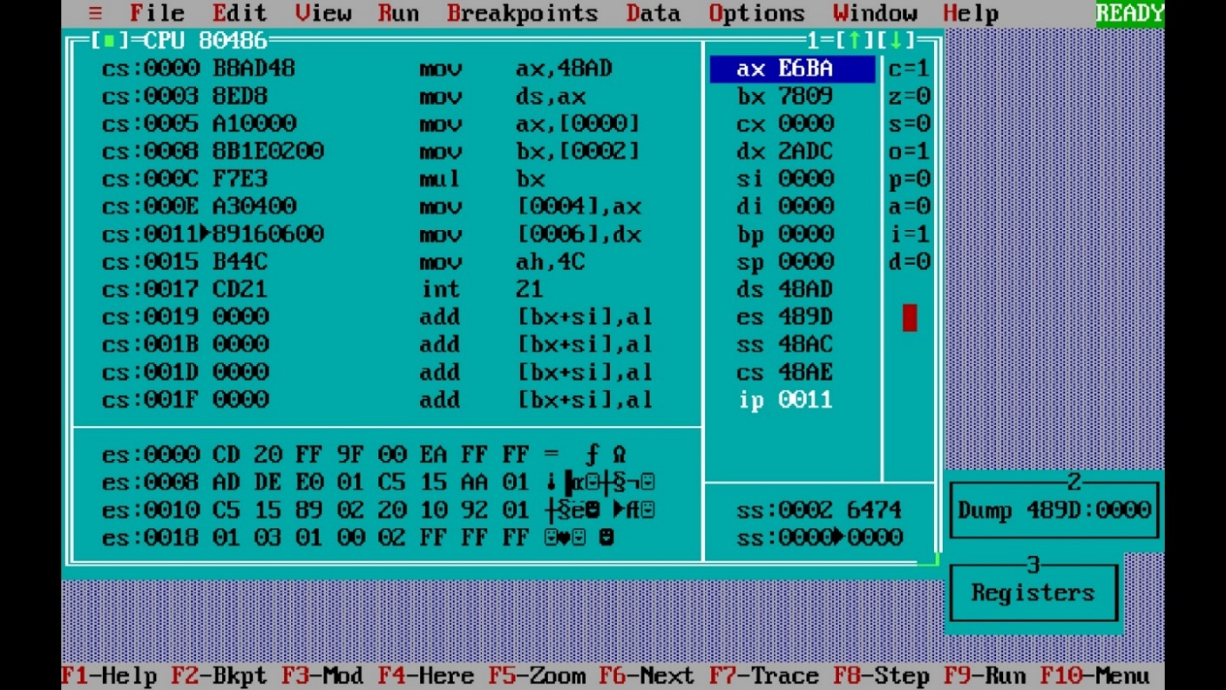

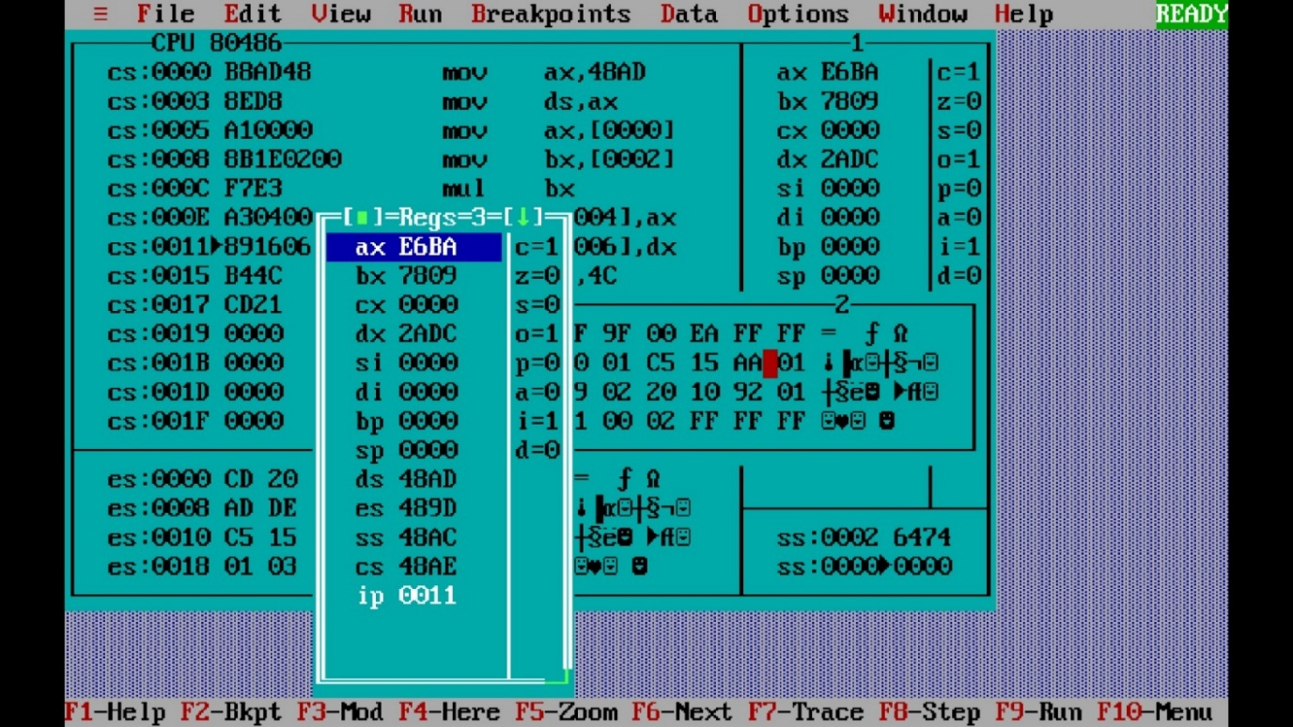

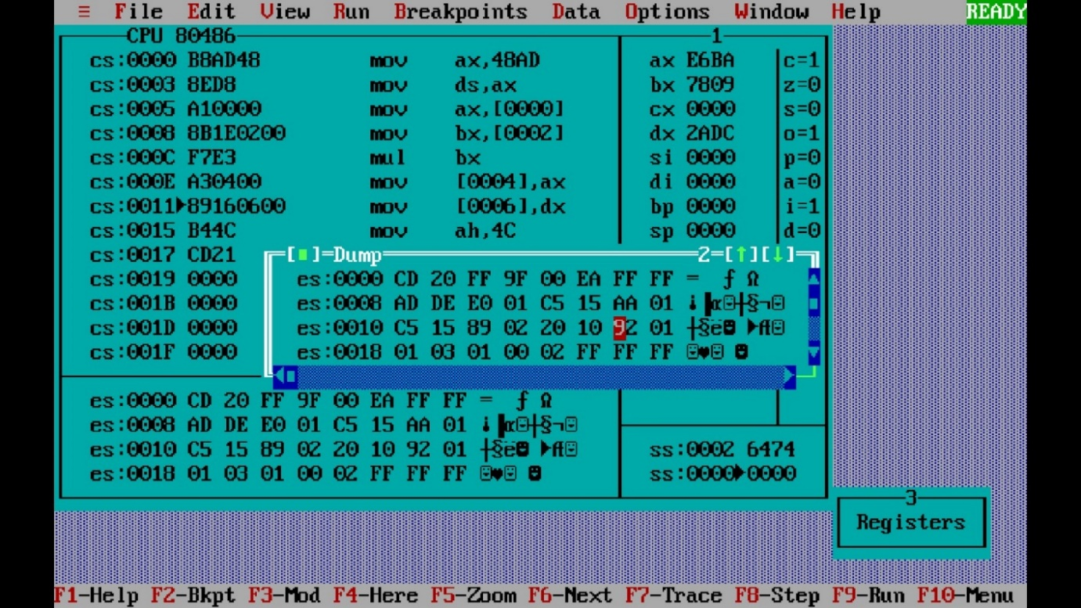

***Experiment 2(g) Title: Assembly language programming to multiply two signed 16 bit numbers using software tool TASM 1.4***

***Name of student: Meet Raut Class Roll Number: 2201084***

***Date of Performance: 05/02/2024***

***Batch: S2-1 Timing: 3:00-5:00 Date of Submission: 05/02/2024***

***Assembly language code***

*data segment # Data segment*

1. *dB 7A5Bh # define 16 bit numbers*
2. *dB 7A5Bh*

*RES_LOW dW 0*

*RES_HIGH dW 0*

*data ends # Assemble directives code segment*

*assume CS: code, DS: data # Assemble directives defining cs and . ds*

*start: # start of code segment mov ax, data*

*mov ds, ax*

*MOV AL, A # move to values to register MOV BL, B*

*MUL BL # multiply the two numbers*

*MOV RES_LOW, AX # move the value to variable*

*MOV RES_HIGH, DX*

*MOV AH, 4CH*

*INT 21H # interrupt handle*

*code ends # Assembler directives to end code*

*end start # Assembler directives to end start*

*Result of multiplication:*

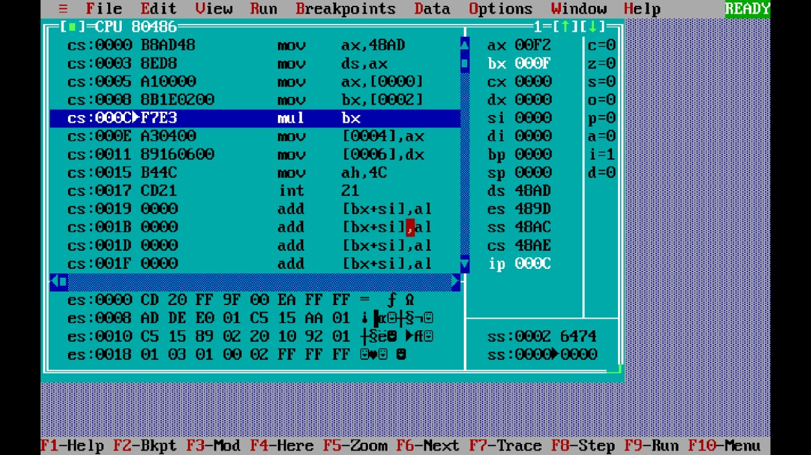

***Experiment 2(h) Title: Assembly language programming to divide 16 bit hexadecimal number with a 8 bit hexadecimal number using software tool TASM 1.4***

***Name of student: Meet Raut Class Roll Number: 2201084***

***Date of Performance: 05/02/2024***

***Batch: S2-1 Timing: 3:00-5:00 Date of Submission: 05/02/2024***

***Assembly language code***

*data segment # Data segment*

*a dw 0008h # variable a define 16 bit number*

*b db 02h # variable b define 8 bit number*

*ans dw ? #variable diff define result of division .*

*data ends # Assemble directives*

*code segment*

*assume cs:code, ds:data # Assemble directives defining cs and ds*

*start: # start of code segment*

*mov ax,data # moving data to ax register- initialization process*

*mov ds,ax # moving ax to dx register -- initialization process*

*mov ax,a # moving first number to ax register*

*mov bl,b # moving second number to bx register*

*div bl # Division and result stored in ax*

*mov ans,ax # result stored in ax moved to variable ans*

*int 3 # breakpoint interrupt*

*code ends # Assembler directives to end code*

*end start # Assembler directives to end start*

*Result of division:*

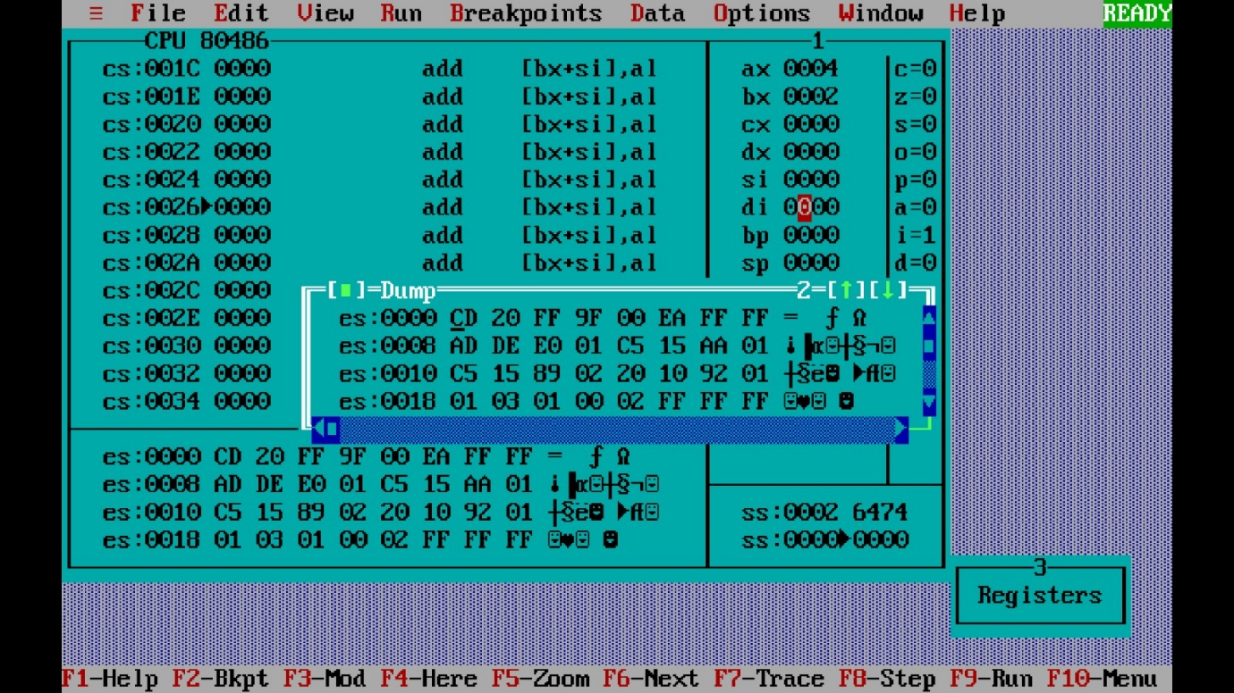

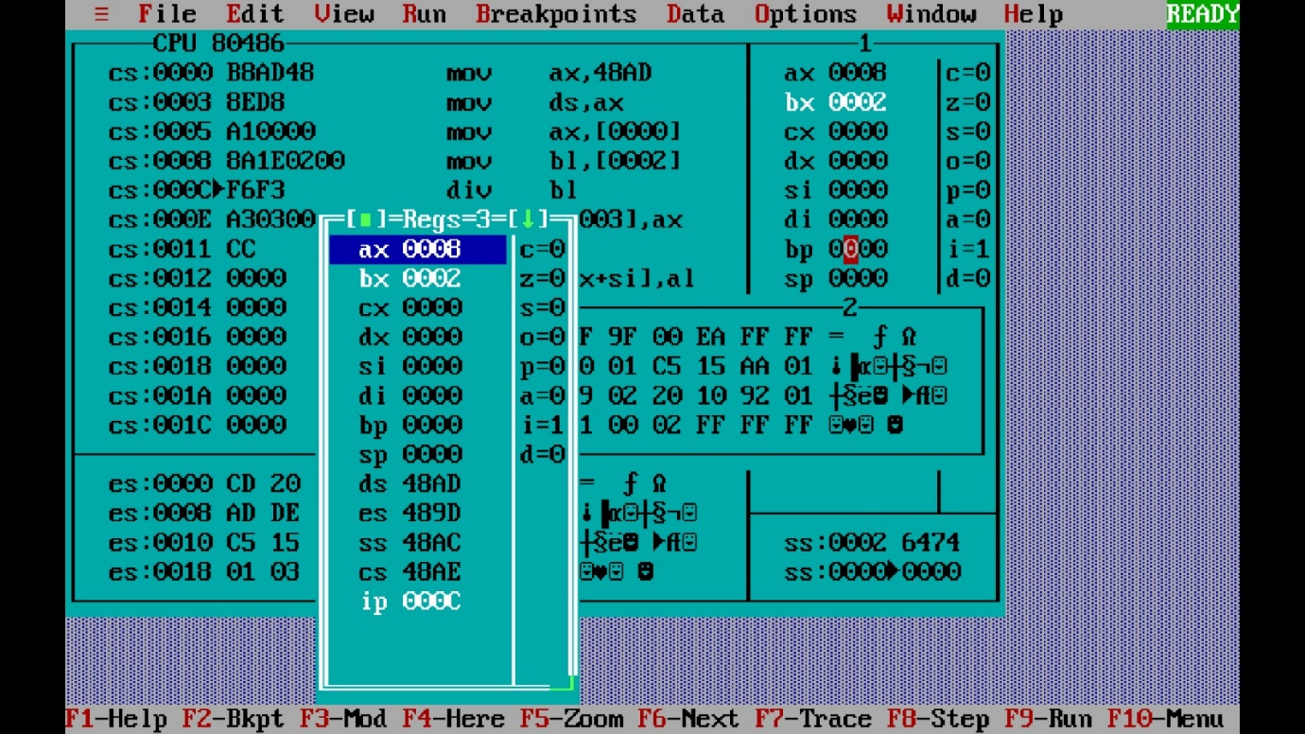

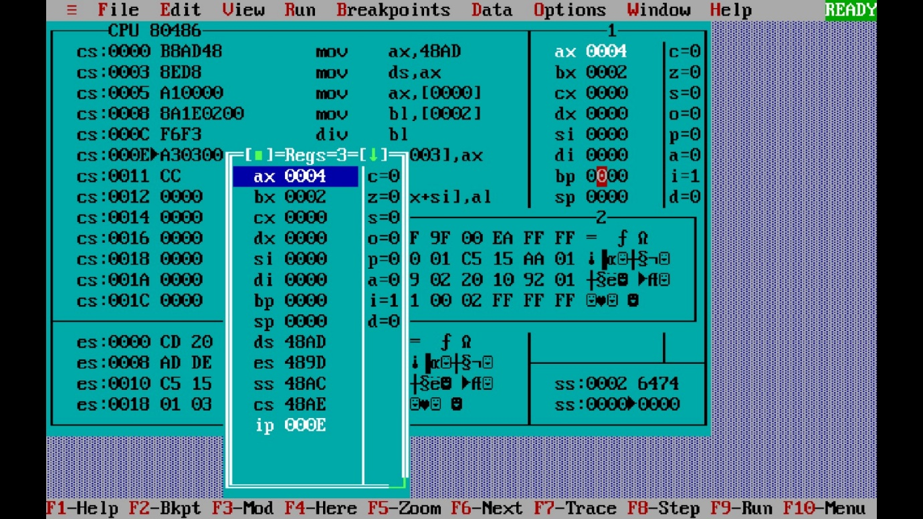

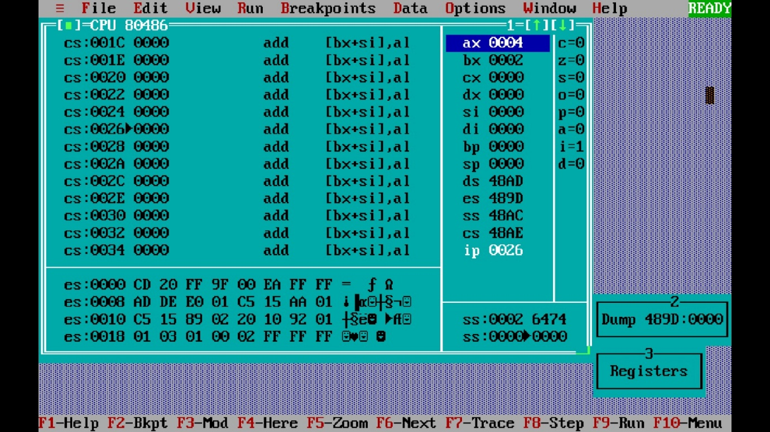

***Experiment 2(i) Title: Assembly language programming to divide two signed 8 bit hexadecimal numbers using software tool TASM 1.4***

***Name of student: Meet Raut Class Roll Number: 2201084***

***Date of Performance: 05/02/2024***

***Batch: S2-1 Timing: 3:00-5:00 Date of Submission: 05/02/2024***

***Assembly language code***

|  |  |
| --- | --- |
| *DATA SEGMENT* | *# Data segment* |
| *NUM1 DB 34H*  *NUM2 DB 69H QUOTIENT DB ?*  *REMAINDER DB ?* | *# define 8 bit numbers* |
| *DATA ENDS* | *# Assemble directives* |
| *CODE SEGMENT* | *# Assemble directives defining cs and ds* |
| *ASSUME CS:CODE, DS:DATA* | *# Assemble directives defining cs and ds* |
| *START:*  *MOV AX, DATA*  *MOV DS, AX* | *# start of code segment* |
| *MOV AX, 0000H*  *MOV AL, NUM1*  *MOV BL, NUM2* | *# move to values to register* |
| *DIV BL* | *# divide the two numbers* |
| *MOV REMAINDER, AH*  *MOV QUOTIENT, AL*  *INT 21H* | *# move to values to respective register* |
| *CODE ENDS* | *# Assembler directives to end code* |
| *END START* | *# Assembler directives to end start* |

*Result of division:*

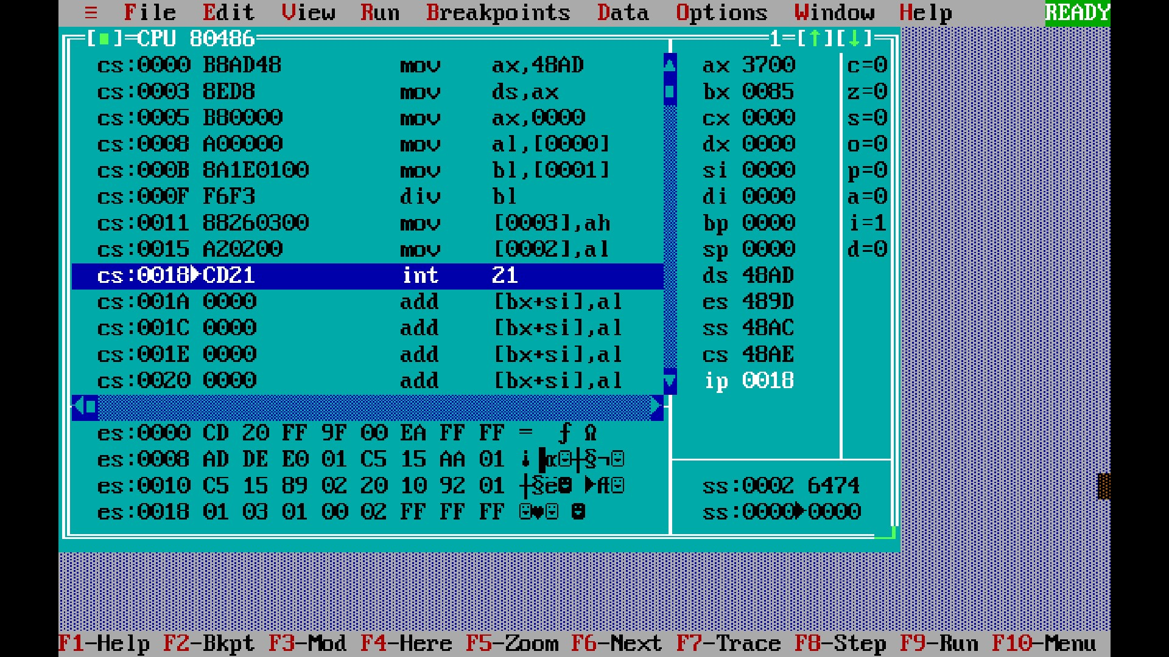

***Experiment 2(j) Title: Assembly language programming to divide two signed 16 bit hexadecimal numbers using software tool TASM 1.4***

***Name of student: Meet Raut Class Roll Number: 2201084***

***Date of Performance: 05/02/2024***

***Batch: S2-1 Timing: 3:00-5:00 Date of Submission: 05/02/2024***

***Assembly language code***

*DATA SEGMENT # Data segment*

*NUM1 DB 1254H # define 16 bit numbers*

*NUM2 DB 1223H QUOTIENT DB ?*

*REMAINDER DB ?*

*DATA ENDS # Assemble directives*

*CODE SEGMENT # Assemble directives defining cs and ds ASSUME CS:CODE, DS:DATA # Assemble directives defining cs and ds*

*START: # start of code segment*

*MOV AX, DATA*

*MOV DS, AX*

*MOV AX, 0000H # move to values to register*

*MOV AL, NUM1*

*MOV BL, NUM2*

*DIV BL # divide the two numbers*

*MOV REMAINDER, AH # move to values to respective register*

*MOV QUOTIENT, AL*

*INT 21H*

*CODE ENDS # Assembler directives to end code*

*END START # Assembler directives to end start*

*Result of division :*

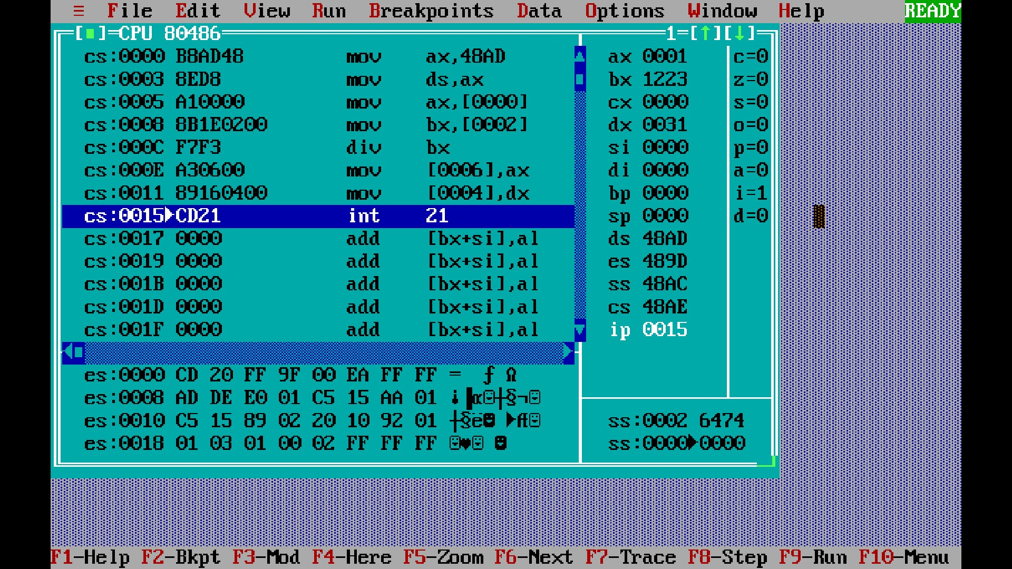

***CONCLUSION: LO 1, LO 2, LO 3 mapped.***

***---------------------------------*****************************-----------------------------------***